LOCATION : GENEL
DATE : 05.05.2017
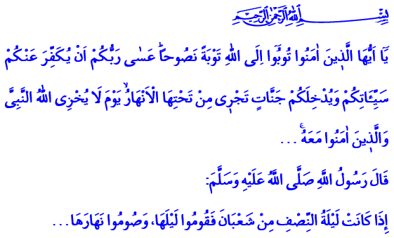
THE NAME OF PENITENCE AND HOPE: REPENTANCE
A Blessed Friday to You, Brothers and Sisters!
In the verse I have recited, the Almighty enjoins: “O you who have believed! Repent to Allah with sincere repentance. Perhaps your Lord will remove from you your misdeeds and admit you into gardens beneath which rivers flow [on] the Day when Allah will not disgrace the Prophet and those who believed with him…”
Brothers and Sisters!
One of the beautiful names of Allah the Exalted is at-Tawwab; He accepts repentance. He forgives those who seek refuge in His vast grace. He is al-Gaffar; He forgives whomever He wishes and whoever wishes it.
As stated in the verse 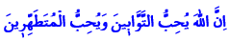, our Lord favors those who repent. He does not turn back hands raised in prayer. He does not let down the hearts dearly invoking. He does not leave destitute those who shed tears with repentance.
Honorable Believers!
We are all humans. We live in a world of tests. And in this test, both the sin and the good deed are for us. We sometimes resist against sins. And sometimes act carelessly and make mistakes. But we know that our Lord’s gate of mercy is wide open against our sins. The thing we need to do is to avoid persisting in mistakes and sins. To demonstrate the virtue of correcting them. To take refuge in our Lord’s grace. To seek His forgiveness with sincere repentance and heartfelt invocation.
Brothers and Sisters!
Repentance is the admission of our helplessness. It is a clear statement of the fact that we sometimes become weak in our pact to Allah. The Almighty taught us the blessing of repentance in the Holy Quran with the story of the first human. Adam (as) and his wife, mother Eve, repented to Allah as such:
“Our Lord! We have wronged ourselves, and if You do not forgive us and have mercy upon us, we will surely be among the losers.”
Brothers and Sisters!
Repentance is one’s commitment to renew and refresh themselves. It is the cleansing of minds and lips that get dirty in time amid the tumult of the world. It is the softening of darkened and hardened hearts. It is the calming and quieting of damaged spirits.
Repentance is a source of solace and hope for us. It is a safe harbor in which we can take refuge in times of crisis. Because even if everyone else abandons us when we make mistakes, our Lord never leaves us. He does not turn His back on us even if everyone else does. “Indeed, Allah does not forgive association with Him, but He forgives what is less than that for whom He wills.” All we need to do is to remain loyal to our faith in His existence and oneness. To never give up on His vast grace. To never deprive ourselves of His forgiveness. All we need to do is to sincerely seek His forgiveness when our weaknesses and sin overwhelm us.
Brothers and Sisters!
We are about to welcome another Bara’at Night which is the harbinger of Ramadan, the season of grace, mercy, and purification. Next Wednesday night we will observe Bara’at Night which is the 15th night of the month of Sha’ban. We will get another unique opportunity to attain our Lord’s salvation and get rid of all troubles, all mistakes that hurt the believers, and all the bad things that do not look good on anyone. Infinite praise be to Allah the Exalted for granting such wonderful opportunity to us in a lifetime that goes by so fast. I wish you a blessed Bara’at Night in advance.
Brothers and Sisters!
Our Prophet (pbuh) informed us that repentance on Bara’at Night will not be turned down. Then let us take this opportunity and repent never to go back to sin again. Let us repent for forgetting about the afterlife from time to time in the tumult of the world. Let us repent for sparing love, attention, and mercy from even our closest ones from time to time. Let us repent for the days we have neglected our spouses, our children, our relatives, orphans, homeless people, and the needy. Let us repent for failing to abide by the rights of one another, who are entrusted to us by the Lord; for failing to be the organs of one body and the bricks in one building as commanded by our Prophet (pbuh). Let us never forget that there is no sinner who will be denied repentance when he feels remorse because his sin is big.

At-Tahrim, 66/8.
Al-A’raf, 7/23.
An-Nisa, 4/48, 116.
Ibn Majah, İkâmetü’s-salavât, 191. Written by: General Directorate of Religious Services

